PROJECT REPORT

**PROJECTTITLE:** Calculating family Expenses using service now

**TEAM ID:** NM2025TMID18787

**TEAM LEADER:** SUNITHA R

**TEAM MEMBER**: HEBA HENNEYA M

**TEAM MEMBER**: LOGESHWARI J

**TEAM MEMBER**: JEEVITHAА В

**DEPARTMENT:** COMPUTER SCIENCE

**COLLEGE NAME:** L.N GOVERNMENT COLLEGE

**YEAR:** 3RD YEAR

**Proposed solution:**

|  |  |  |
| --- | --- | --- |
| **SI.NO** | **PARAMETER** | **DISCRIPTION** |
| 1 | Problem statement (problem to be solved ) | Manual ticket assignment is slow and inefficient, causing delays and lower customer satisfaction. We need a faster, automated way to assign tickets to the right support agents based on their skills, workload, and ticket priority. |
| 2 | Idea/solution description | Use an automated ticket assignment system that quickly matches incoming tickets to the right support agents based on their skills, availability, and ticket priority.  This will speed up response times, balance workloads, and improve customer satisfaction |
| 3 | Noveity/uniqueness | The unique aspect of this solution is the smart, automated matching of tickets to agents using real-time data like skills, workload, and ticket priority. Unlike basic assignment methods, it can adapt instantly to changes, ensuring faster, fairer, and more accurate ticket distribution. |
| 4 | Social impact/customer satisfaction | helps customers get faster, more accurate support, which increases their satisfaction and trust in the service. It also reduces stress and overload for support agents, creating a better work environment and improving overall team performance. |
| 5 | Business model/revenue model) | The solution can be offered as a subscription-based software (SaaS), where businesses pay monthly or yearly fees based on the number of users or tickets handled. Additional revenue can come from premium features like advanced reporting, AI-based routing, and system customization. |
| 6 | scalability of the solution | The solution can easily grow with the business by handling more tickets, agents, and support teams without losing speed or accuracy. It can be used by small teams or large organizations and can integrate with existing support tools to support future expansion. |

**STREAMLINING TICKET ASSIGNMENT FOR EFFICIENT SUPPORT OPERATIONS**

**MILESTONE -1 USERS**

**ACTIVITY 1:create Users**

**PURPOSE:**

User creation helps set up profiles for support agents with their skills, availability, and roles. This makes it easier to quickly assign tickets to the right person, improving support speed and customer satisfaction.

**USES**

User creation saves key details about each support agent, like their skills and availability. This helps the system quickly assign tickets to the right agent, making support faster and more efficient

.

**STEPS:**

1. Open service now.
2. Click on All >> search for user
3. Select Users under system security
4. Click on new
5. Fill the following details to create a new user
6. Click on submit Create one more user
7. Create another user with the following details
8. Click on submit

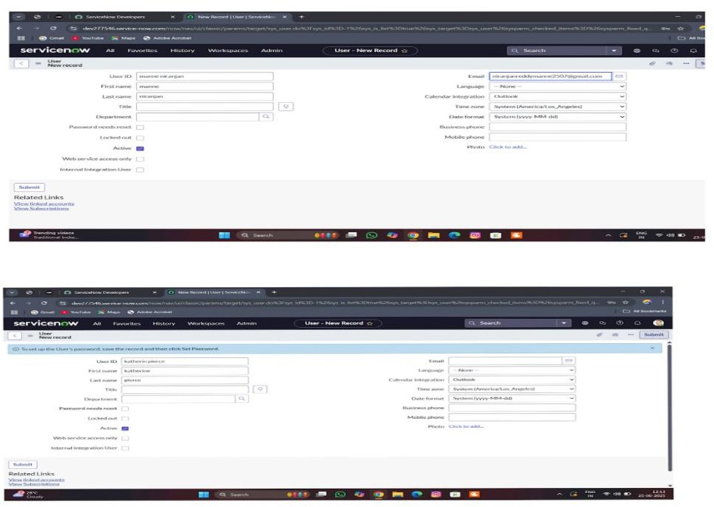

**MILESTONE -2 GROUPS**

**ACTIVITY 1: create Groups**

**PURPOSE:**

Group creation helps organize support agents into teams based on their skills, departments, or ticket types. This makes it easier to assign tickets to the right team, improving ticket handling speed and ensuring the right experts work on the right issues.

**USES:**

Group creation helps organize support agents into teams based on skills or departments. This makes it easier to quickly assign tickets to the right team, improving support speed, workload balance, and overall efficiency.

**STEPS:**

1. Open service now.
2. Click on All >> search for groups
3. Select groups under system security
4. Click on new
5. Fill the following details to create a new group
6. click on submit

Create one more Group

1. Create another group with the following details
2. Click on submit

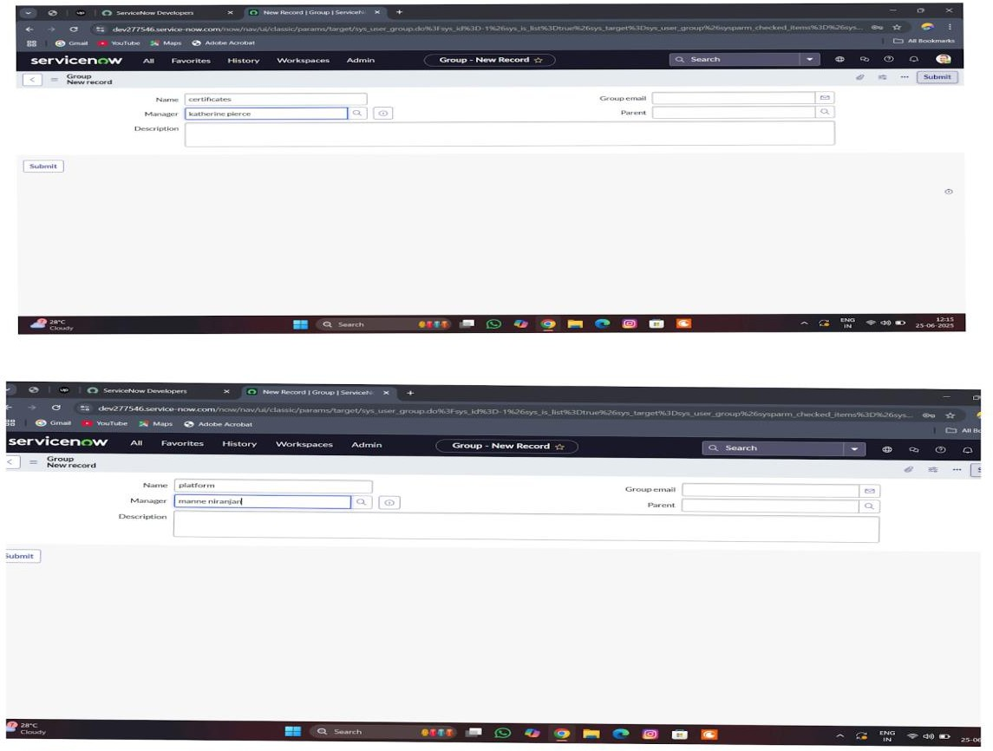

**MILESTONE -3 ROLES**

**ACTIVITY 1: Create Roles**

**PURPOSE:**

Roles creation defines what each user can do in the system, such as managing tickets, handling specific tasks, or overseeing teams. It helps control access, organize responsibilities, and ensure the right people have the right permissions to keep the support process smooth and secure.

**USES:**

Roles creation helps assign specific permissions and responsibilities to each user. It ensures that agents, team leads, and managers can only access the features they need, making the ticket assignment process organized, secure, and efficient.

**STEPS:**

1. Open service now
2. Click on All >> search for roles
3. Select roles under system security
4. Click on new
5. Fill the following details to create a new role
6. Click on submit Create one more role
7. Create another role with the following details
8. click on submit

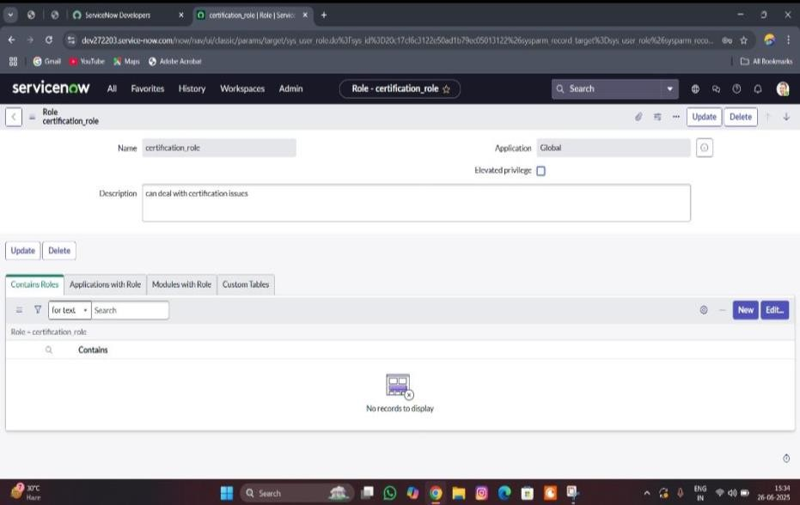

**MILESTONE -4 TABLE**

**ACTIVITY-1 Creating Table**

**PURPOSE:**

Table creation is used to store, organize, and display important data like user details, ticket information, groups, and roles in a clear and structured way. This helps the system easily manage and track tickets, making the assignment process faster, more accurate, and easier to control.

**USES:**

Table creation helps store and organize data like users, tickets, groups, and roles. It makes it easy to manage, track, and quickly assign tickets to the right agents or teams.

**STEPS:**

1. Open service now.
2. Click on All >> search for tables
3. Select tables under system definition
4. Click on new
5. Fill the following details to create a new table Label : Operations related

Check the boxes Create module & Create mobile module

1. Under new menu name : Operations related
2. Under table columns give the columns
3. Click on submit

Create choices for the issue filed by using form design Choices are

*unable to login to platform

* 404 error

*regarding certificates

*regarding user expired

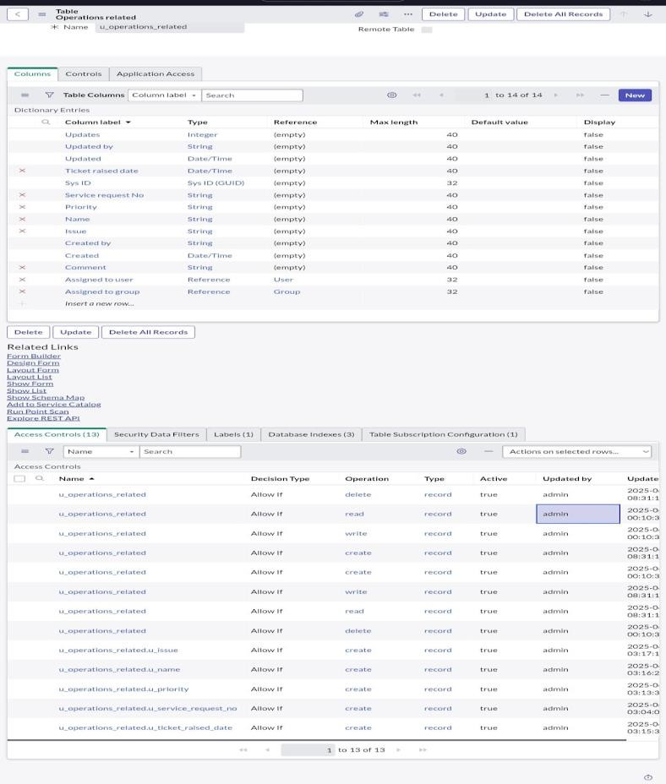

**MILESTONE -5 ASSIGN ROLES & USERS TO GROUP**

**ACTIVITY-1 Assign roles & users to certificate group**

**PURPOSE:**

Assigning roles and users to a certificate group helps make sure the right people handle the right tickets.

It ensures tickets go to qualified agents quickly and safely.

**USES:**

It helps the system automatically send specific tickets to the right certified agents or teams, making ticket assignment faster, more accurate, and handled by qualified people.

**STEPS:**

1. Open service now.
2. Click on All >> search for tables
3. Select tables under system definition
4. Select the certificates group
5. Under group members
6. Click on edit
7. Select Katherine Pierce and save
8. Click on roles
9. Select Certification_role and save

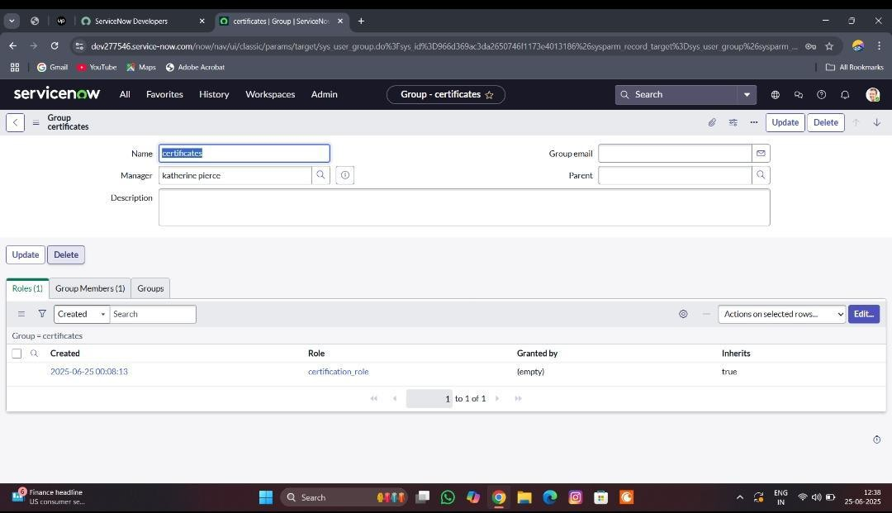

**ACTIVITY -2 Assign roles & users to platform group PURPOSE:**

Assigning roles and users to a platform group helps organize agents based on the platforms or tools they support. This ensures tickets related to specific platforms are quickly assigned to the right experts, improving accuracy and response time

**USES:**

It helps the system automatically send platform-specific tickets to the right agents who are trained for that platform, making ticket assignment faster, more accurate, and efficient.

T shirt

**STEPS:**

1. Open service now.
2. Click on All >> search for tables
3. Select tables under system definition
4. Select the platform group
5. Under group members
6. Click on edit
7. Select Manne Niranjan and save
8. Click on role
9. give platform role and save

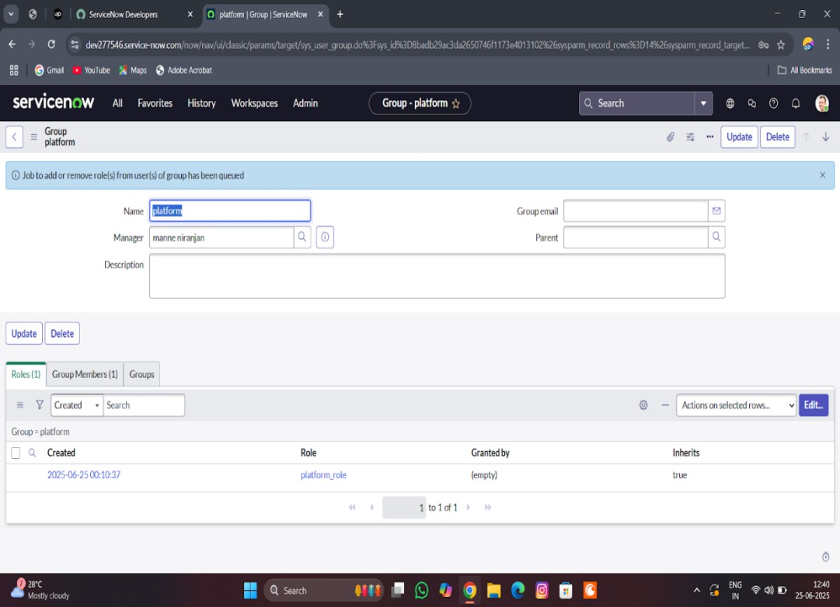

**MILESTONE-6 ASSIGN ROLE TO TABLE**

**ACTIVITY-1 Assign role to table**

**PURPOSE:**

Assigning roles to a table helps control who can view, edit, or manage the information in that table. It ensures that only the right users with proper permissions can access or update ticket, user, or group data, keeping the system organized, secure, and efficient.

**USES:**

It controls who can see or update the table data, making sure only the right people can manage tickets, users, or groups. This keeps the ticket assignment process safe, organized, and efficient.

**STEPS:**

1. Open service now.
2. Click on All >> search for tables
3. Select operations related table
4. Click on the Application Access
5. Click on u_operations_related read operation
6. Click on the profile on top right side
7. Click on elevate role
8. Click on security admin and click on update
9. Under Requires role
10. Double click on insert a new row
11. Give platform role
12. And add certificate role
13. Click on update
14. Click on u_operations_related write operation
15. Under Requires role
16. Double click on insert a new row
17. Give platform role
18. And add certificate role

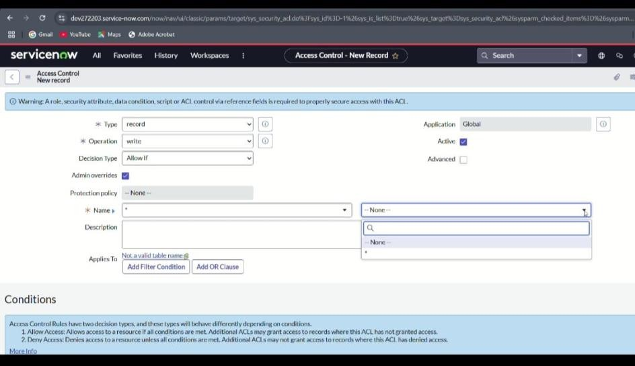

**MILESTONE-7 CREATE ACL**

**ACTIVITY-1 Create ACL**

**PURPOSE:**

Creating an ACL (Access Control List) helps set rules about who can view, create, edit, or delete specific data. This keeps the ticket assignment process secure by making sure only authorized users can access or change important information.

**USES:**

Creating an ACL helps control user access to tickets, tables, and other system data. It makes sure only the right people can view or update information, keeping the ticket assignment process secure and well-managed.

**STEPS:**

1. Open service now.
2. Click on All >> search for ACL
3. Select Access Control(ACL) under system security
4. Click on new
5. Fill the following details to create a new ACL
6. Scroll down under requires role
7. Double click on insert a new row
8. Give admin role
9. Click on submit
10. Similarly create 4 acl for the following fields

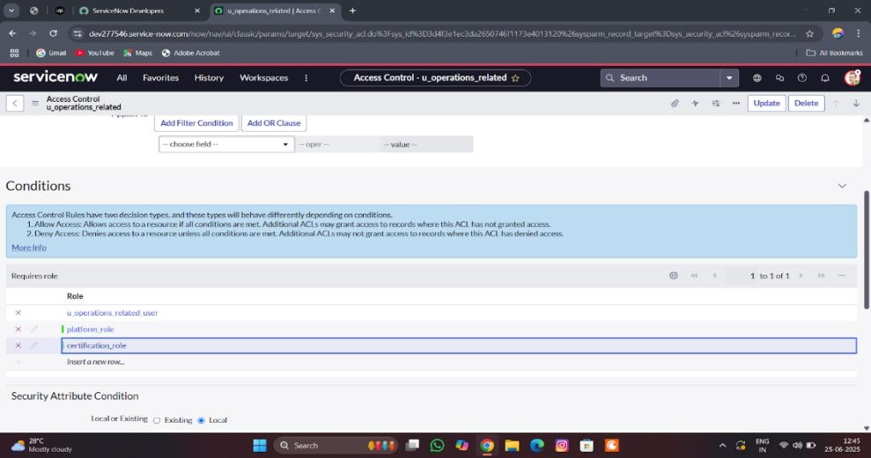

**MILESTONE -8 FLOW**

**ACTIVITY-1 Create a Flow to Assign operations ticket to group**

**PURPOSE:**

Purpose of Creating a Flow to Assign Operations Ticket to Group: The purpose is to automate the process of directing operations-related tickets to the right support group.

**USES:**

It automatically routes operations tickets to the correct group, speeding up ticket handling and improving support efficiency.

**STEPS:**

1. Open service now.
2. Click on All >> search for Flow Designer
3. Click on Flow Designer under Process Automation.
4. After opening Flow Designer Click on new and select Flow.
5. Under Flow properties Give Flow Name as “ Regarding Certificate”.
6. Application should be Global.
7. Select Run user as “ System user ” from that choice.
8. Click on Submit.
9. Click on Add a trigger
10. Select the trigger in that Search for “create or update a record” and select that.
11. Give the table name as “ Operations related ”.
12. Give the Condition as Field : issue

Operator : is

Value : Regrading Certificates

1. After that click on Done
2. Now under Actions.
3. Click on Add an action.
4. Select action in that search for “ Update Record ”.
5. In Record field drag the fields from the data navigation from left side
6. Table will be auto assigned after that
7. Give the field as “ Assigned to group ”
8. Give value as “ Certificates ”
9. Click on Done.
10. Click on Save to save the Flow.
11. Click on Activate.

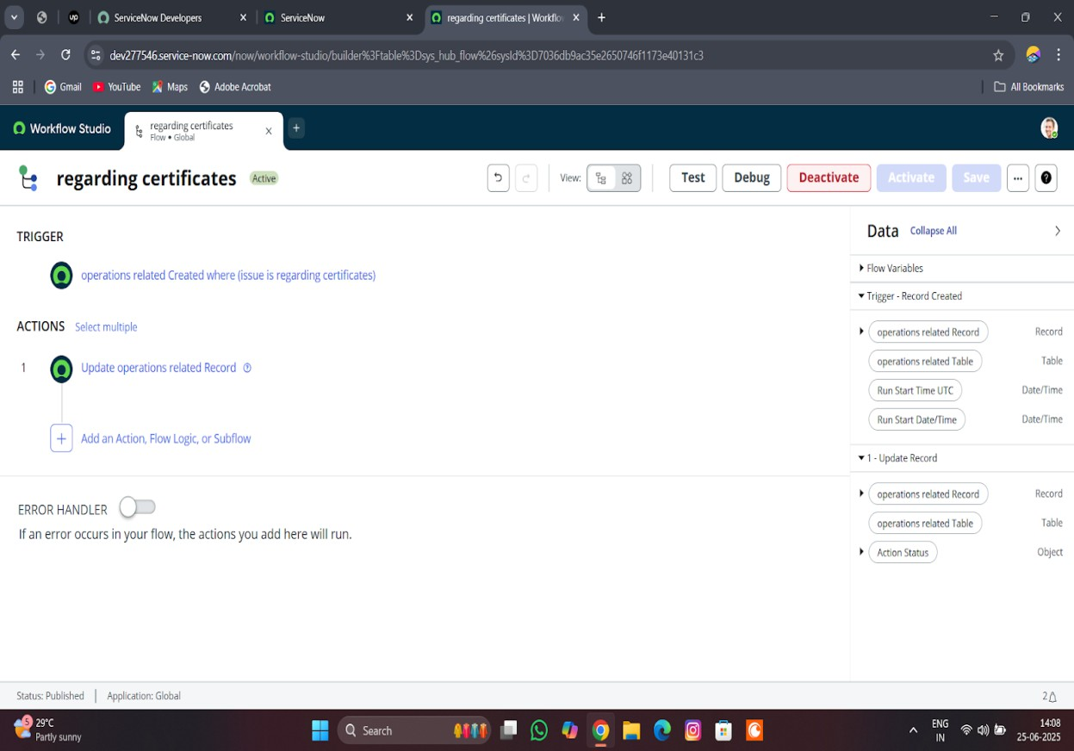

**ACTIVITY-2 Create a Flow to Assign operations ticket to Platform**

**PURPOSE:**

To automatically assign operations tickets to the right platform experts, ensuring faster and accurate support.

**USES:**

It routes operations tickets to the correct platform specialists automatically, improving response time and support accurate

**STEPS:**

1. Open service now.
2. Click on All >> search for Flow Designer
3. Click on Flow Designer under Process Automation.
4. After opening Flow Designer Click on new and select Flow.
5. Under Flow properties Give Flow Name as “ Regarding Platform ”.
6. Application should be Global.
7. Select Run user as “ System user ” from that choice.
8. Click on Submit.
9. Click on Add a trigger
10. Select the trigger in that Search for “create or update a record” and select that.
11. Give the table name as “ Operations related ”.
12. Give the Condition as Field : issue Operator : is

Value : Unable to login to platform

1. Click on New Criteria Field : issue

Operator : is Value : 404 Error

1. Click on New Criteria Field : issue

Operator : is

Value : Regrading User expired

1. After that click on Done.
2. Now under Actions.
3. Click on Add an action.
4. Select action in that search for “ Update Record ”.
5. In Record field drag the fields from the data navigation from left side
6. Table will be auto assigned after that
7. Give the field as “ Assigned to group ”.
8. Give value as “ Platform ”
9. Click on Done.
10. Click on Save to save the Flow.
11. Click on Activate.